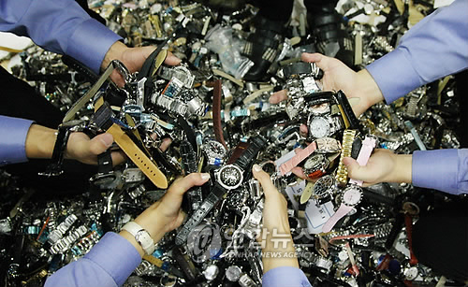
Fake World

China of fake, by fake, for fake
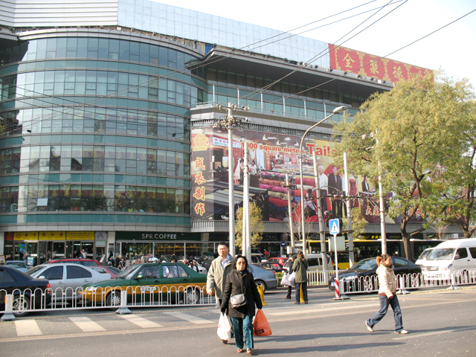

This is one of the famous landmarks in Beijing, which is well-known for selling fake goods. It's called "Xiusui". Allmost every tourist visits "Xiusui while traveling in Beijing. It's quite interesting that all the stores in "Xiusui" department store specialize in fakes must get the permission to sell fake merchandise from government . Does it mean that fake sales are legal? China is fun!

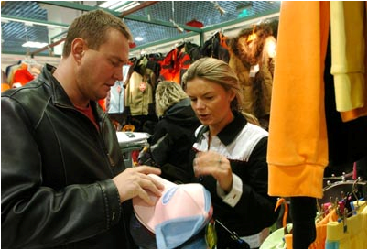

It's possible to purchase all the name-brand items here. There are tons of fake product lines such as clothing, bags, watch and shoes. Some Chinese staff are frequently heard serving foreigners speaking English fluently for sales.

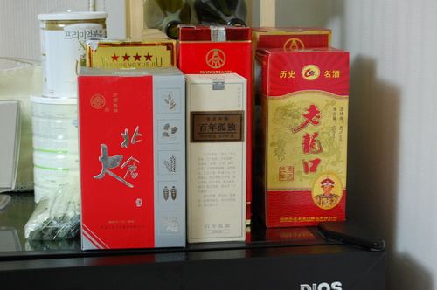

But, there's a different type of counterfeit which can take one's life away. This is a fake of "Baijiu" which is a popular alcohol in China. It was reported that 4 people died and 19 people had became blind after drinking it.

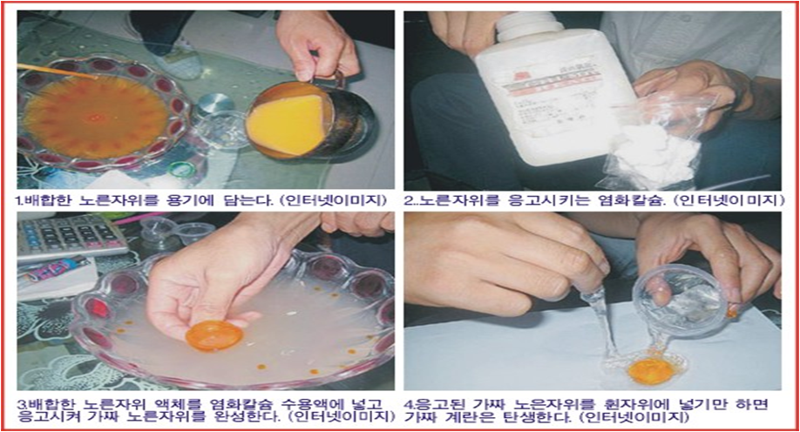

Here's another fake item showing negativity. It's an egg people pretty much can see in their diets. Can you distinguish what the fake is? This fake egg consists of chemical elements, which accumulate in people's bodies and can cause some problems if they accumulate too much.

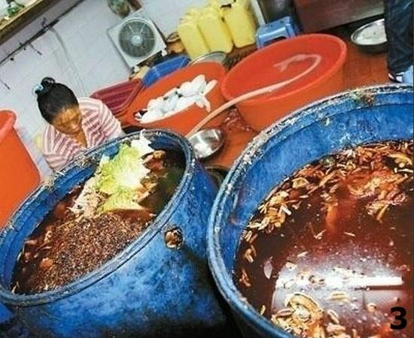
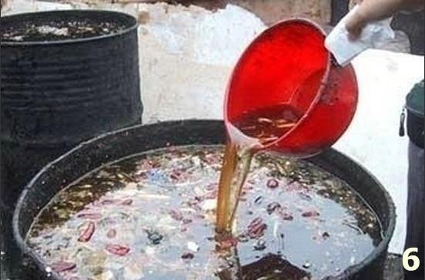

This is the process of making fake cooking oil, which gave deadly shock and extreme terror to everybody around the world. Dirty oil squeezed from garbage is mixed with unknown, miscellaneous oils and fat of pork. Through this disgusting process, fakes are made and distributed to restaurants, and general homes.

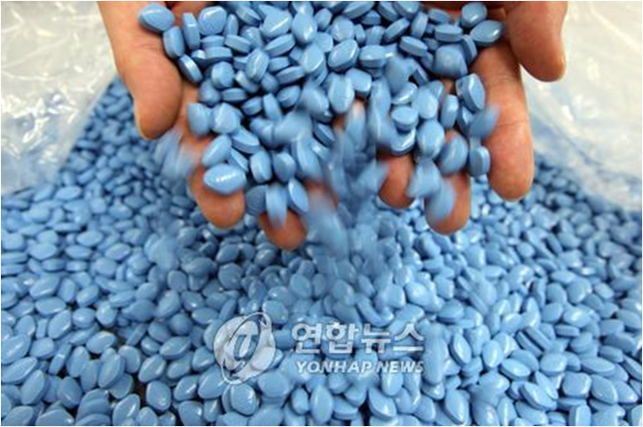

They even have fake milk and viagra which threatens people's lives in China. There's nothing China can not make. Anything can be made as China decides

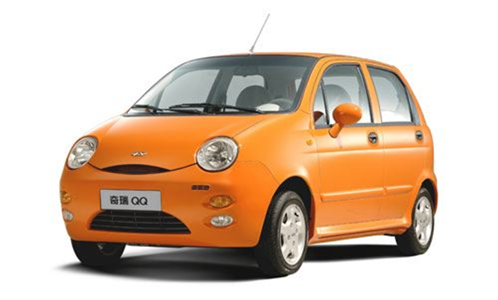

This is another type of fake which takes intellectual and creative values. In China, they have "QQ" vehicle which is completely the same as the Matiz made by Hyndai, Korea like in the photo above. Hyundai filed a lawsuit against QQ for copyright violation. it lost the suit though, which is so pathetic.

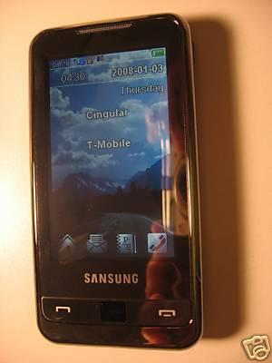
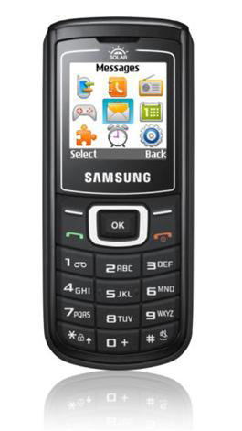
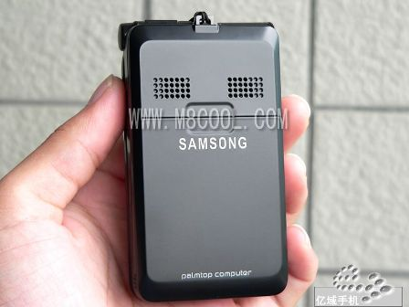

<Genuine one> <Fake> <Fake>

These are famous mobile phones of "Samsung" and are fake. Can you notice a minor spelling error in the "Samsung" logo. Their thoughtless fake production gives a considerable damage to the corporate image and brings tremendous losses of sales revenue.

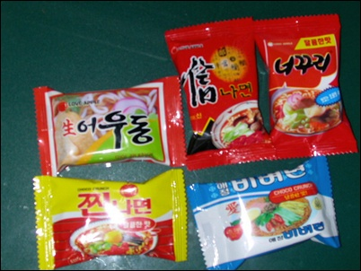
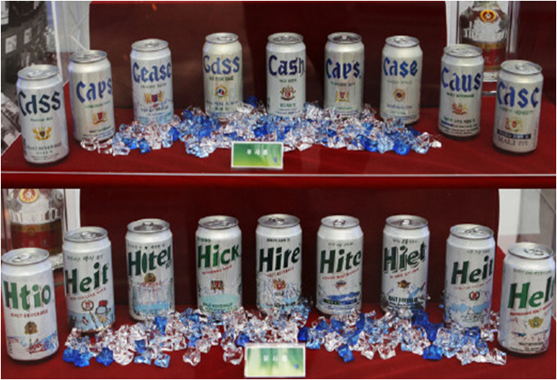

Many companies might give up developing new products worldwide and might be reluctant to produce them as long as the Chinese fake industry continues to be implemented.

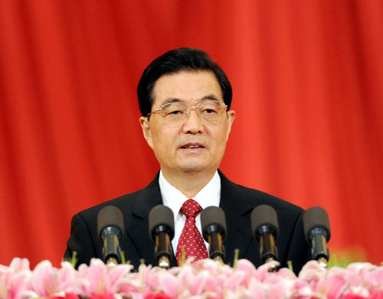

Why is this illegal practice repeated even if it has a negative effect on people's health as well as sales revenue of corporations. Probably, it might be the thought of president "Hujintao" who belives it's ok for anyone poor to make fakes if they can get out of poverty?

