**Job Interview**

**Before the interview**  
- Research the company, position, etc.   
- Think about what questions might be, what answers you will give  
- Don't script it out, just think about some key ideas you want to get across   
- Think of your own questions to ask the interviewer (not about salary, hours, etc.)   
- Practice with a friend  
- Make sure you have all the documents you need,   
- You know how to get to where the interview is,   
- How long it will take you to get there (you want to arrive 5-15 minutes early)

**Appearance for Interviews**  
**Men**🡪 Suit, belt, dress shoes, tie is optional,   
**Women**🡪 Suit or skirt and blouse, no running shoes, the shirt and skirt should not be too short or revealing, make sure the skirt is long enough that you can sit down comfortable   
🡪 Don’t confuse club attire with business attire   
 NO🡪 backpacks, overly bright colors, heavy makeup, hats, phones or ipods out or on, sunglasses

**Body Language At the Interview**🡪 Sit up straight, don’t lean back or forward, arms at your sides  
🡪 Don't put your hands in your pocket, across your body, or behind your back,   
🡪 Don't play with your hair, fingers or jewelry, Don't move your legs a lot  
🡪 Don't stare but do make eye contact, don’t be looking all over the room, pay attention, smile, don’t appear too nervous  
🡪 Speak with a varied tone, don’t be monotone   
🡪 Shake hands with the interviewer before and after the interview, make sure your grip is firm but not crushing

**During the interview**   
🡪 You are selling yourself🡪 Your goal is to convince the interviewer that you should be selected   
🡪 Be thorough but honest, don’t answer questions with 'yes' or 'no', the more info you give the better as long as it Is related to the topic   
🡪 Try to provide examples from your experience,   
🡪 Pay close attention to what the interviewer is asking, if you don’t understand a question ask for them to repeat it or clarify it   
🡪 Think for a very short while about your answers before answering, its better to take a second and think about it than say something silly   
🡪 Don't overemphasize your weaknesses, be negative about your past coworkers, jobs, school, etc.   
🡪 Don't discuss personal issues

**The End of the Interview**  
🡪 Ask the job-related questions you thought up  
🡪 Make sure the interviewer knows how to contact you in case there is anything else they need from you   
🡪 Thank the interviewer for the consideration, shake their hand

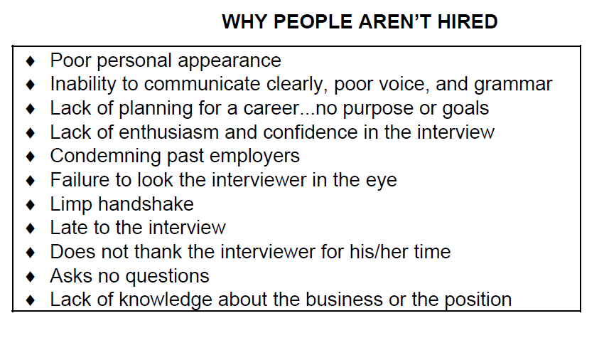

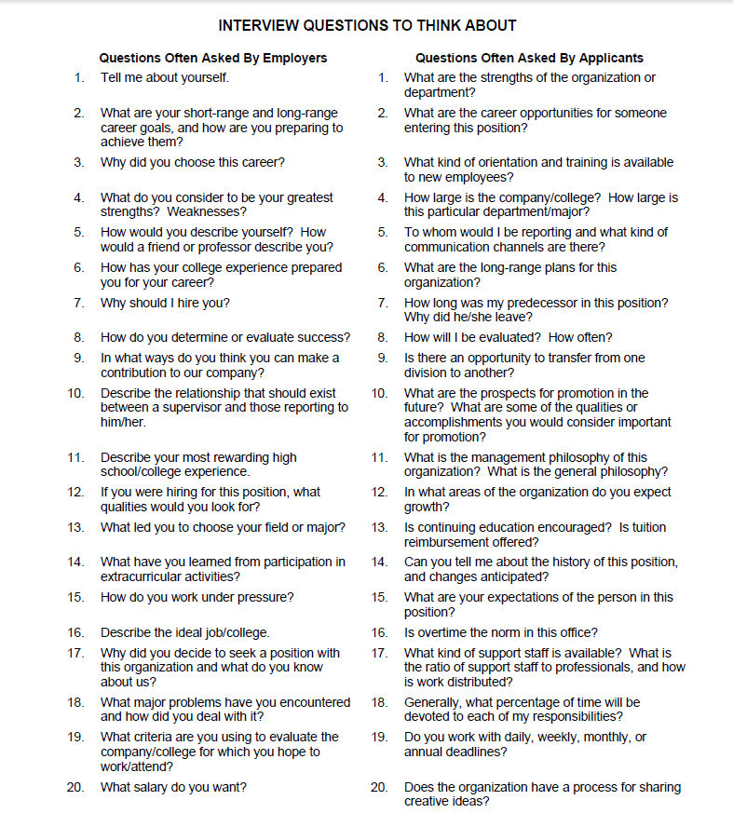

**Interview Structure**

|  |  |
| --- | --- |
| Greeting / Small Talk | * basic greeting and short question about weather/finding the office |
| Introductions | Interviewer introduces himself or herself briefly  Next, ask the interviewee to tell you about one of the following:  🡪 His/her educational background  🡪 His/her employment history |
| Questions x 2 | Ask a few of these questions:   * Why do you want to work for us? * Please tell me about an obstacle you faced in your previous position and what you did to overcome it. * What is your weakness? * What can you contribute to my company? |
| Abstract Question x 1 | * What does it mean to be successful? * What do you look for in an employer? * What does "customer service" mean to you? |
| Future Question x 1 | * Where do you see yourself in 10 years? * Please tell me how working at (my company name) fits with your career goals? |
| Scenarios x 2 | Think of scenarios the student could face (even ridiculous ones) and get him/her to tell you how he/she would behave. Get creative Examples:   * another employee is stealing supplies/etc. Would you report him? * you are not getting along with your manager or co-worker. How would you resolve this problem? * Marketing/Sales: Please sell me this (pen). * Teacher: students don't seem interested in lesson/material. People are sleeping. What would you do to improve the atmosphere and their attitudes?   These are just some examples. Try to think of scenarios that are relevant to the job the person wants. |
| Practical questions | * Are you willing to work over-time? How much? Unpaid? |
| Wrap-up | Say thank you and that you will contact him/her in a few days with the result. |